ACC 2010 Fall 2017: Excel Project (90 points) LuVMuscles Manufacturing:

Reading for this Project
You should consult applicable chapters from our text book and the My Accounting Lab study guide for extra guidance. My Accounting Lab also contains an excellent tutorial on using Excel.

Project Objectives
Employers expect graduates to have detailed knowledge of using Excel to produce relevant information for decision making. Whilst many of you may already use Excel, others might have limited knowledge of the software. It is essential that you become proficient in using Excel, as it is a core instrument in the arsenal of all business professionals. You will work through this assignment while utilizing this tutorial as your guide for applying the native tools coded into the software. By the end of this assignment, you should feel comfortable with the basic functions in Excel. All your spreadsheets should be readable and easy to use. Remember that formatting your Excel analysis reflects on your professionalism because aesthetics matter in business!

Note that this project is a self-directed learning exercise, and you will not be given a lecture on how to complete it. Excel knowledge comes from using and learning the package. If you get stuck on the basic functions then consult these notes, consult the help facility in Excel, use Google or YouTube to find a solution to your problem. There are many wonderful Excel tutorials on the Internet. This project tests your basic accounting knowledge by asking you to prepare the journal entries, trial balance, income statement, statement of retained earnings and balance sheet for a service entity.

Microsoft Excel Review Problem
Prepare the following accounting statements for LuVMuscles, LLC for the year ended December 31, 2017. Use the data provided and the supplemental information included in this project to construct the company’s financial statements, linking the statements together. Deliver the following:

- Record Journal Entries & Adjusting Entries for Transactions in the General Ledger
- Prepare the Adjusted Trial Balance, Income Statement, Statement of Retained Earnings & Balance Sheet for Year Ending December 31, 2017
- Prepare the Statement of Cash Flows for Year Ending December 31, 2017
- For 5 points Extra Credit, record the Closing Entries

1. Build Your Excel Foundation
To begin, open a new Excel workbook. At the bottom are tabs that reference the available sheets. Each new Excel workbook contains 1 - 3 worksheets (depending on your version of Excel), labeled Sheet1, Sheet2 and Sheet3. To add additional sheets, go to the Insert menu and choose the Worksheet option. This will add a sheet to the left of the active sheet (the sheet you are currently in). Another way to add a sheet is to left click the icon next to the last sheet in your workbook.. To make the sheet names more useful, double click on the tab for Sheet1. This will highlight the current sheet name and allow you to type over it. Rename the first worksheet to Journal Entries. While you’re at it, you might as well rename the next sheets T accounts, Trial Balance, Income Statement and R/E, Balance Sheet and Cash Flow Statement. Your layout should appear similar to this:

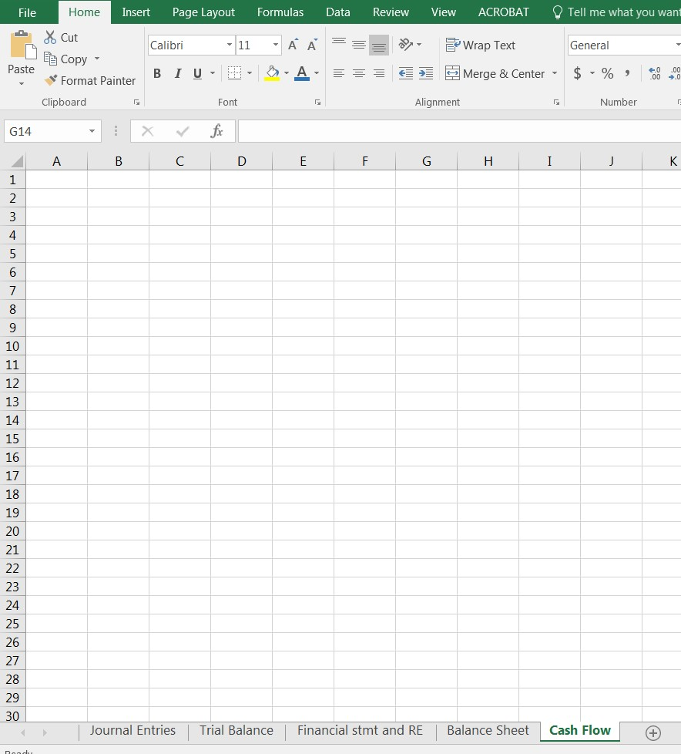

Journal Entries:
When creating your journal entry sheet, please label it correctly. It should look similar to below. You do not need to color code it if you do not wish, I just did it to help highlight the different sections.

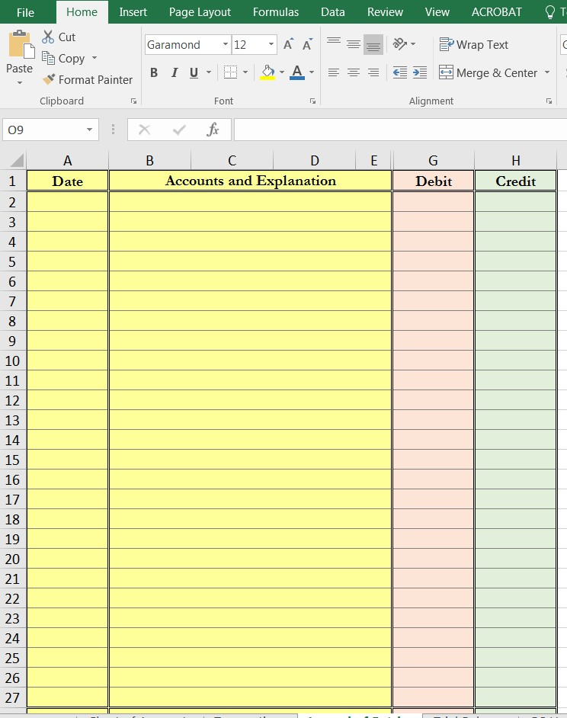

T Accounts
Set up your T Accounts similar to this. Again, no need to color code:

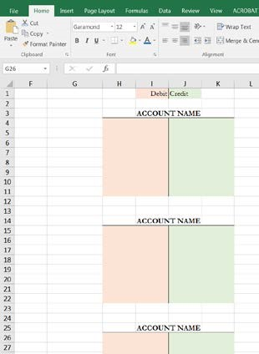

Trial Balance:
Set up your trial balance similar to this. Please note that you will have more accounts than are shown below.

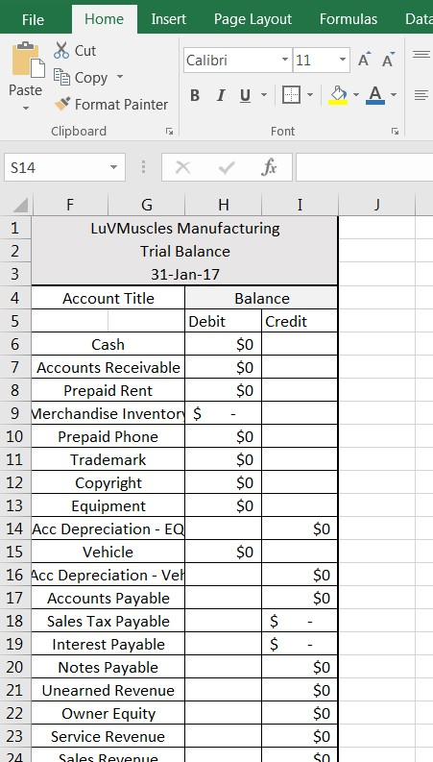

Financial Statements:
Income Statement: Follow the format for the income statement that is shown on page 270 of Chapter 5, separating out service revenue from sales revenue. You may combine all expenses under one heading “expenses” instead of separating selling and administrative expenses. As there will be no other income or tax expense in this problem, no need to include that portion in your Excel spreadsheet.

Statement of Retained Earnings: Follow the format for the statement of retained earnings as outlined on page 80 of chapter 2.

Balance Sheet: Follow the format for the balance sheet as outlined on page 80 of chapter 2.

Cash Flow Statement: Follow the format for the cash flow statement as outlined on page 739 of chapter 14.

Copy/Paste and Move Formulas: The standard commands Edit, Copy (Ctrl+C) and Edit, Paste (Ctrl+V) work great for quickly copying single cells or multiple-cell ranges. Cut (Ctrl+X) and Paste is another function you should become familiar with. When copying and pasting formulas, it’s important to understand how Excel treats cell references. Unlike copying, moving a formula from 1 cell to another doesn’t change the formula. A special option for copying a formula may occasionally come in handy if you want to copy (not move) a formula without changing its cell references in any way. Here’s how: 1. Make the cell that holds the formula to copy the current cell 2. Drag over the formula that appears in the Formula Bar 3. Edit, Copy to put a copy of the Formula Bar formula on the Windows Clipboard 4. Hit the Escape key 5. Make the cell current in which you want to locate the copied formula 6. Edit, Paste. Excel locates a copy of the formula in the new cell without changing any cell references in the formula.

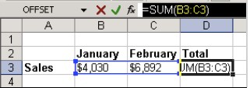

Color Coding: Be sure to get the color coding correct if you intend to use it at all (not required yet can be helpful both for the learning process and professionally). Color coding allows anyone to immediately pick up your files and know what can be changed (assumptions) and should not be changed (formulas). Yes, you can figure out this yourself by pressing F2 or Ctrl + U in every cell, but both those methods are more timeconsuming and clumsy to use. So get the color coding right. Here are the universal standards for direct links to cells in other spreadsheets vs. constants (hard-coded numbers) vs. formulas:

- Blue Font Color: All hard-coded (i.e. manually entered) numbers; used for historical financial data and also for many input cells in the Assumptions part of models
- Black Font Color: All formulas; also used for formulas that include links to other spreadsheets or workbooks, but which are not direct links (i.e. if you’re adding 2 numbers that are both from other spreadsheets)
- Green Font Color: All direct links to cells in other spreadsheets or workbooks
- Red Font Color: Calculations

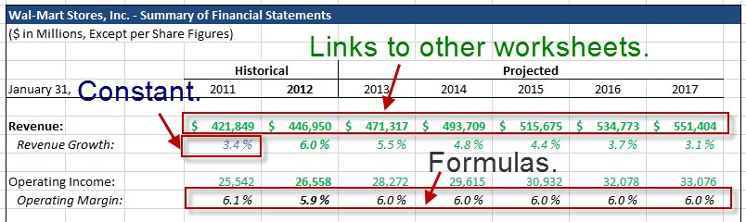

What about text? Leave it all formatted in black font color. Technically, you should use blue because it’s hardcoded but that makes it harder to read models so we avoid doing so. We do use the blue font color if there’s an input cell that accept text, however.

Parts of a Formula: A formula can contain any or all of the following: functions, references, operators and constants. For example:
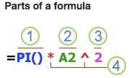
- Functions: The PI() function returns the value of pi:3.142…
- References: A2 returns the value in cell A2
- Constants: Numbers or text values entered directly into a formula, such as 2
- Operators: The ^ (caret) operator raises a number to a power and the * (asterisk) operator multiplies numbers

Using Constants in Formulas: A constant is a value that always stays the same and is not calculated. For example, the date 10/9/2017, the number 2010 and the text Quarterly Earnings are all constants. An expression or a value resulting from an expression is not a constant. If you use constants in a formula instead of references to cells (e.g. =30+70+110), the result changes only if you modify the formula. In general, it’s best to place constants in individual cells where they can be easily changed if needed, then reference those cells in formulas.

Using Calculation Operators in Formulas: Operators specify the type of calculation that you want to perform on the elements of a formula. Excel follows general mathematical rules for calculations, which is parentheses, exponents, multiplication and division, and addition and subtraction. There are 4 different types of calculation operators: 1. Arithmetic 2. Comparison 3. Text Concatenation 4. Reference.

Arithmetic Operators: Use the following arithmetic operators to perform basic mathematical operations, such as addition, subtraction, multiplication, or division, combine numbers, and produce numeric results:

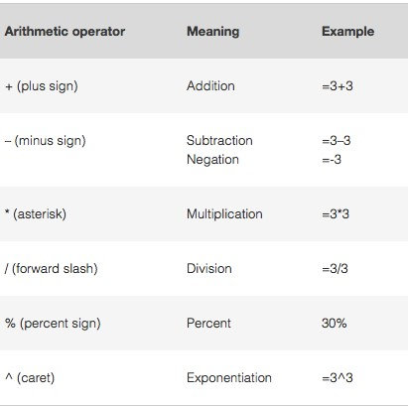
The Order Excel Performs Operations and Calculations in Formulas: In some cases, the order in which a calculation is performed can affect the return value of the formula so it’s important to understand how the order is determined and how you can change the order to obtain the results you want. Formulas calculate values in a specific order and always begin with an equal sign (=). Excel interprets the characters that follow the equal sign as the elements to be calculated (the operands), such as constants or cell references. These are separated by calculation operators. Excel calculates the formulas from left to right according to a specific order for each operator in the formula. If you combine several operators in a single formula, Excel performs the operations in the order shown in the following table. If a formula contains operators with the same precedence – for example, if a formula contains both a multiplication and division operator – Excel evaluates the operators from left to right.
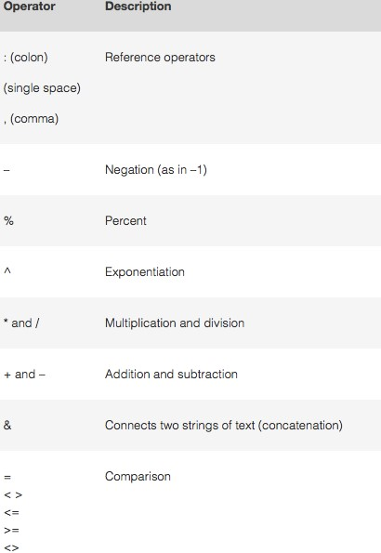

Using Parentheses in Formulas: To change the order of evaluation, enclose in parentheses the part of the formula to be calculated 1st. For example, the following formula produces 11 because Excel performs multiplication before addition. The formula multiplies 2 by 3 and then adds 5 to the result: =5+2*3

In contrast, if you use parentheses to change the syntax, Excel adds 5 and 2 together and then multiplies the result by 3 to produce 21: =(5+2)*3

In the following example, the parentheses that encloses the 1st part of the formula force Excel to calculate B4+25 first and then divide the result by the sum of the values in cells D5, E5 and F5:

=(B4+25)/SUM(D5:F5)

Borders, Fonts and Fill Colors: Normally, you only include borders around the financial statements and supporting statements such as those for revenue and expense models. You should not overuse borders or your spreadsheets will be more difficult to read and interpret. You can include bottom borders beneath or above date rows, but you should not make a box there. In normal cells, you would only apply outside borders if you have an input cell and you want to change it to the blue/yellow/black border format discussed. Only use 10, 11 or 12-point font sizes and standard font types include Garamond, Calibri, Helvetica and Times New Roman. You rarely want to use any type of fill color to change the background color of cells. Keep most areas white and only do this for the titles of all the statements, key summary rows and perhaps on any graphs or charts you create. See below:

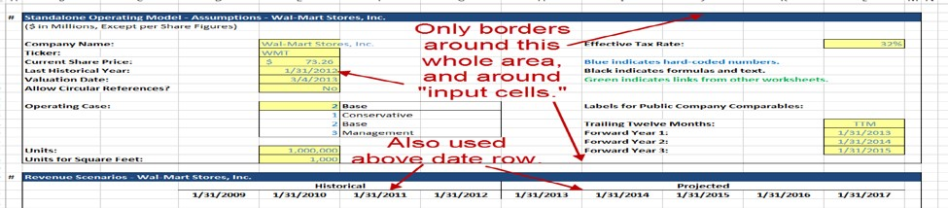

Alignment: In your spreadsheets, you should keep most things Left-Aligned and set to General horizontal alignment.

2. Viewing Multiple Worksheets and References
You will use the data you entered in the journal entry worksheet to create the T accounts. The problem is that we have to switch the view from 1 worksheet to another and back again. Excel allows you to view multiple worksheets at once. Click on View and select New Window. Then select View Side by Side in the View menu. You should now be able to simultaneously view 2 worksheets and can adjust the position and size of each window. Play around with this.
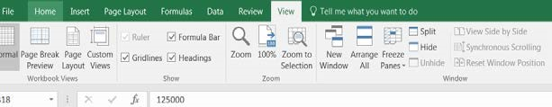

In order to use Excel effectively, you must use formulas to link data from each worksheet. As we wish to use information from the journal entry worksheet in the T account worksheet, we must include linking formulae that allow us to subsequently update the numbers in the data section during future periods.

Using References in Formulas: A reference identifies a cell or a range of cells on a spreadsheet, and tells Excel where to look for the values or data you want to use in a formula. You can use references to use data contained in different parts of a spreadsheet in 1 formula or use the value from 1 cell in several formulas. You can also refer to cells on other sheets in the same workbook and other workbooks. References to cells in other workbooks are called links or external references. By default, Excel uses the A1 Reference Style, which refers to columns with letters (A through XFD, for a total of 16,384 columns) and refers to rows with numbers (1 through 1,048,576). These letters and numbers are called row and column headings. To refer to a cell, enter the column letter followed by the row number. For example, B2 refers to the cell as the intersection of column B and row 2.
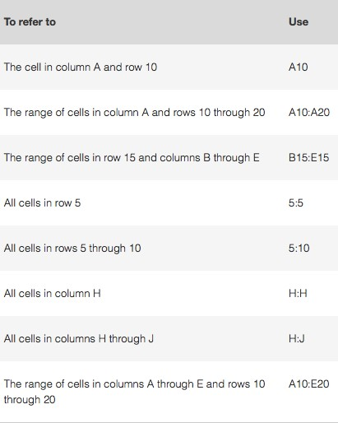

In the following example, the AVERAGE function calculates the average value for the range B1:B10 on the worksheet named Marketing in the same workbook:
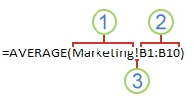
- Refers to the worksheet named Marketing
- Refers to the range of cells from B1 to B10
- The exclamation point (!) separates the worksheet reference from the cell range reference

Note that if the referenced spreadsheet has spaces or numbers in it then you need to add apostrophes (‘) before and after the spreadsheet name like =’123’!A1 or =’JanuaryRevenue’!A1. For example, the formula to add 2 cells together in the journal entry sheet that are contained in the T account sheet would appear as: = JournalEntries!b9+Jouranl Entries!b10

If you linked the two worksheets correctly, changes to any of the figures within the Journal Entries worksheet will be automatically updated in the T account worksheet. Do not hard code any data within the T account worksheet - draw on the journal entries sheet using linking formulae.

The Difference between Absolute, Relative and Mixed References:

Relative References: A relative cell reference in a formula, such as A1, is based on the relative position of the cell that contains the formula and the cell the reference refers to. If the position of the cell that contains the formula changes, the reference is changed. If you copy or fill the formula across rows or down columns, the reference automatically adjusts. By default, new formulas use relative references. For example, if you copy or fill a relative reference in cell B2 to cell B3, it automatically adjusts from =A1 to =A2:

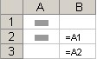

Absolute References: An absolute cell reference in a formula, such as $A$1, always refer to a cell in a specific location. If the position of the cell that contains the formula changes, the absolute reference remains the same. If you copy or fill the formula across rows or down columns, the absolute reference does not adjust. By default, new formulas use relative references, so you may need to switch them to absolute references. For example, if
you copy or fill an absolute reference cell in cell B2 to Cell B3, it stays the same in both cells: =$A$1

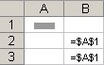

Mixed References: A mixed reference has either an absolute column and relative row, or absolute row and relative column. An absolute column reference takes the form $A1, $B1 and so on. An absolute row reference takes the form A$1, B$1 and so on. If the position of the cell that contains the formula changes, the relative reference is changed and the absolute reference does not change. If you copy or fill the formula across rows or down columns, the relative reference automatically adjusts and the absolute reference does not adjust. For example, if you copy or fill a mixed reference from cell A2 to B3, it adjusts from =A$1 to =B$1:

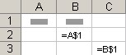
Additionally, you may choose to freeze panes within your spreadsheet so that you can navigate the data more efficiently without losing your place. For example, you can freeze just the top row in a sheet that contains the titles to your columns of data, or you can freeze just the far left column that contains the categories of information. Or, you may choose to freeze your spreadsheet anywhere on the spreadsheet by choosing a cell and clicking Freeze Panes. Locate this function under the View menu:

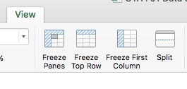

Troubleshooting Formulas: Excel includes a set of auditing tools on a Formula Auditing toolbar that can help troubleshoot formulas or just make it easier to see value relationships in a worksheet. The most often used auditing tools are Trace Precedents and Trace Dependents. Turn on the Formula Auditing toolbar by choosing View then Toolbars the Formula Auditing. Clicking Cell B5 in this illustration and then clicking the Trace Precedents auditing tool displays a blue border around the cells that the SUM function in Cell B5 uses along with an arrow connecting the summed cells in the formula:

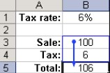

Clicking Cell B1 at left and then clicking the Trace Dependents auditing tool displays an arrow that shows where the tax rate value is used in a formula in this illustration:

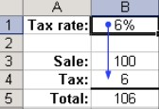

This Excel information is not exhaustive, but should be used as a quick reference if you are new to Excel.

Company Background

LuVerne Lancaster is a 26-year old certified personal trainer whose income is derived from two sources: First, she earns $25 per hour per client booked through her corporate gym; and secondly, she earns $100 per hour per client booked through her new personal website. LuVerne’s popularity is validated by her 70% client retention rate and $0 average customer acquisition cost which is sufficiently driven by word-of-mouth and doesn’t require her to rely on pre-paid advertising expenses. As a recent graduate, she has recently expanded the number of hours she is available per week and wishes to organically grow her personal training business while weaning herself off her low-margin clients booked through her commercial gym. She also has ulterior motives for terminating her corporate relationship. LuVerne specializes in training two types of customers: athletes of all skill levels searching for new training methods and philosophies; and women intimidated by traditional gym equipment and immature instructors overly-reliant on shouting and peer-pressure to motivate their clients. Further, she understands that some clients just want to try as many new fitness ideas as possible.

Thus, LuVerne has found a niche using alternative psychological tricks to motivate clients while incorporating battle-inspired exercise equipment forgotten over time and recently enjoying a popularity revival that commercial gyms are slow if not resistant to implement. Two notable exceptions have been the adoption of kettle bells and battle ropes. LuVerne’s fondness for the utility and cost-effectiveness of incorporating battleinspired equipment (steel maces, steel clubs and wood clubs) instead of traditional free-weights, pulley systems and treadmills/stationary bicycles is not only based on sound science, but the equipment’s ergonomic design allows greater mobility and strength in muscles, soft tissues and ligaments, and significantly reduces the risk of injury. LuVerne advocates that her clients purchase steel maces and/or clubs because they are inexpensive, durable (if not indestructible) and allow a greater range of exercises that one can perform in the comfort of their home.

• Steel maces and clubs are based off old Persian and Indian military training philosophies advocating soldiers train with equipment heavier than their battle weapons so their weapons seem lighter allowing greater functionality and devastation in actual battle. The same concept is used in baseball where batters waiting “on deck” add a weight to their bat (and take multiple practice swings) so the bat seems lighter than normal when the weight is removed.

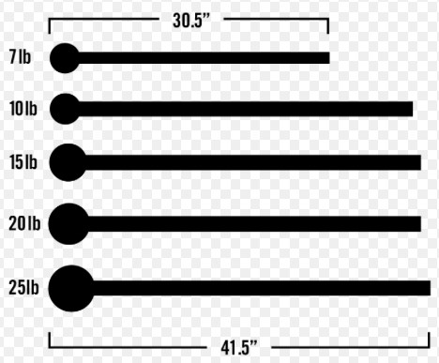
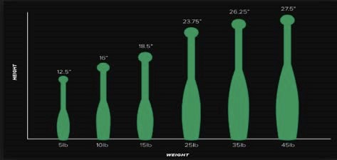

Transactions 2017
LuVerne has prudently saved her earnings over her young career and accumulated sufficient capital that she is ready to start her journey towards financial independence. With $15,000 accumulated, she took the first step and registered her personal training company, LuVMuscles LLC, with the State of Colorado and funded it with $15,000 in equity to avoid starting her career dependent on commercial loans and obligations to return interest. With this cash flow, she purchased a simple yet sufficient website to book clients online that also allows her to manage her schedule and client communications via a smartphone app. She forecasts $35,000 for first-year sales.

January 2017
- 01/02/2017 Opened a company checking and savings account with JP Morgan Chase, depositing her $15,000 of savings. She also registered LuVMuscles LLC with the State of Colorado for $50.
- 01/02/2017 Pre-paid rent for three months for $2,100 for a warehouse space to use as her training studio. Payments will be made quarterly on the 1st.
- 01/04/2017 Paid retail price for one full set of steel maces ranging from 7lbs to 25lbs at a cost of $296, 1 full set of steel club pairs ranging from 7lbs to 45lbs for a cost of $842 and paid $200 for 2 sets of 5lb wood “Indian” clubs. She paid $133 for shipping. The equipment will be depreciated using straight-line over two years. No residual value is anticipated.
- 01/10/2017 Purchased a website and registered the domain from Squarespace.com for a recurring payment of $18 per month, based on signing an annual contract. Payments will be made on the 10th of each month.
- 01/11/2017 Paid $100 for an extra cell-phone and phone number for company use and signed a 12month contract with pre-payment for 3 months of service for $150. Payments are made the 11th of each month.
- 01/12/2017 Received $300 payment for services performed.
- 01/15/2017 Received $125 payment for services performed.
- 01/17/2017 Received $300 payment for services performed.
- 01/18/2017 Received $150 payment for services performed.
- 01/22/2017 Received payments for $50 and $75 for services performed.
- 01/25/2017 Paid $50 in printing costs for flyers and posters promoting her business.

February 2017
- 02/01/2017 Paid $100 for warehouse utilities.
- 02/02/2017 Received the following payments: $50, $300, $150, $450, $750 and $225 for services performed.
- 02/03/2017 Paid $300 for maintenance on her personal vehicle.
- 02/06/2017 Received $600 pre-payment for services to be performed.
- 02/10/2017 Payment made to Squarespace.com for $18.
- 02/15/2017 Received $750 pre-payment for services to be performed.
- 02/20/2017 Performed $375 worth of pre-paid services.
- 02/22/2017 Paid $50 for 10 shirts with the LuVMuscles company logo.
- 02/27/2017 Received the following payments for services performed: $100, $250, $375, $550 and $600
- 02/28/2017 Performed $450 worth of pre-paid services.

March 2017
- 03/01/2017 Paid $100 for warehouse utilities.
- 03/03/2017 Performed $175 worth of pre-paid services.
- 03/10/2017 Payment made to Squarespace.com for $18.
- 03/11/2017 LuVerne’s clients love the company Tshirts she wears while working with them and many have asked to purchase them. LuVerne contacts her supplier who will offer her free shipping if she purchases over 100 shirts per order. Her cost is $5 per shirt. LuVerne purchases 200 Tshirts with terms 2/10 net 45. She will sell the Tshirts for $15 each + $1 of sales tax. She will use the FIFO inventory system.
- 03/12/2017 Performed $150 worth of pre-paid services.
- 03/14/2017 Received $100, $250, $600, $250 and $400 payments for services performed.
- 03/15/2017 Performed $75 worth of pre-paid services.
- 03/18/2017 LuVerne paid her Tshirt invoice, taking advantage of the discount offered.
- 03/23/2017 Received $50 payment for services performed.
- 03/24/2017 Received $750 pre-payment for services to be performed.
- 03/27/2017 Received the following payments: $75, $300, $150, $150, $75 and $225 for services performed.
- 03/30/2017 Paid $500 for maintenance on her personal vehicle.
- 3/30/2017 LuVerne sold 25 Tshirts in March.

April 2017
- 04/01/2017 Paid $100 for warehouse utilities
- 04/01/2017 Pre-paid rent for 3 months at $700 per month. Paid $100 for warehouse utilities.
- 04/05/2017 Paid $10,000 in cash for a lightly used truck for business purposes that she expects to own for the next 5 years and hopes to sell for $3,000. She elected to use straight-line depreciation.
- 04/08/2017 Received $500 payment for services performed.
- 04/09/2017 Received $150 payment for services performed.
- 04/10/2017 Payment made to Squarespace.com for $18.
- 04/11/2017 Received prepayment of $300 for services to be performed
- 04/11/2017 Pre-paid 3 months for company phone plan at $150.
- 04/14/2017 Received $450, $600, $750, $250 and $500 for services performed
- 04/15/2017 Received $600 pre-payment for services to be performed.
- 04/17/2017 Received $75 payment for services performed.
- 04/20/2017 Remitted March sales tax to the state
- 04/20/2017 Paid $400 for a new set of tires on her work vehicle.
- 04/28/2017 Performed $500 worth of pre-paid services.
- 04/30/2017 Sold 40 Tshirts in April

May 2017
- 05/01/2017 Paid $100 for warehouse utilities.
- 05/01/2017 Paid $300 for a Trade Mark to the name LuVMuscles and $55 for a Copyright. LuVerne consulted with Cody, an attorney friend, who offered some pro bono information that, given LuVerne’s recent start of her business, and the statistics involved with start-ups in the health and fitness category, her Trademark and Copyright will probably have a useful life of 10 years. If LuVern’s business is successful, this can be adjusted to fit the market.
- 05/03/2017 Sold $300 worth of services on account.
- 05/04/2017 Performed $125 worth of pre-paid services.
- 05/07/2017 Received $150, $300, $800, $250 and $150 payment for services performed.
- 05/07/2017 Received $200 payment for services performed.
- 05/08/2017 Received $75 payment for services performed.
- 05/10/2017 Payment made to Squarespace.com for $18.
- 05/20/2017 Remitted sales tax for April to the state
- 05/20/2017 Received $75, $200, $300 and $50 payments for services performed.
- 05/22/2017 Received the following payments: $50, $400, $150, $300, $250 and $600 for services performed.
- 5/31/2017 Received $300 for billed services from 5/3/2017
- 05/31/2017 Sold 50 Tshirts in May

June 2017
- 06/01/2017 Paid $100 for warehouse utilities.
- 06/10/2017 Payment made to Squarespace.com for $18.
- 06/11/2017 Purchased another 200 Tshirts as there was a sale for $4 each. Terms given were 2/10 net 45. Shipping was still free.
- 06/13/2017 Received the following payments: $350, $325, $400, $225, $75 and $150 for services performed.
- 06/14/2017 Received $150 payment for services performed.
- 06/15/2017 Paid $250 for a large banner with her logo to hang in her studio.
- 06/16/2017 Sold $450 worth of services on account.
- 06/18/2017 Paid for shirts purchased on 6/11.
- 06/18/2017 Received the following payments: $75, $300, $500, $150, $75 and $275 for services performed.
- 06/20/2017 Remitted May sales tax due to the state.
- 06/20/2017 Received $75, $250, $600 and $750 payment for services performed.
- 06/24/2017 Performed $200 worth of pre-paid services.
- 06/29/2017 Received $750 pre-payment for services to be performed.
- 06/30/2017 Sold 45 Tshirts in June

July 2017
- 07/01/2017 Pre-paid rent for 3 months at $700 per month. Paid $100 for warehouse utilities.
- 07/05/2017 Paid $50 in printing costs for flyers and posters promoting her business.
- 07/10/2017 Payment made to Squarespace.com for $18.
- 7/10/2017 Received the following payments: $1,000, $250, $350, $50 and $150 for services performed.
- 07/11/2017 Sold $300 worth of services on account.
- 07/11/2017 Pre-paid 3 months for company phone plan at $150.
- 7/12/2017 Received payment for services sold on 6/16
- 07/13/2017 Received $100 payment for services performed.
- 07/17/2017 Performed $150 worth of pre-paid services.
- 07/18/2017 Sold $250 worth of services on account.
- 07/20/2017 Remitted June sales tax due to the state.
- 07/27/2017 Received the following payments: $75, $400, $150, $250, $75 and $500 for services performed.
- 07/28/2017 Received $150 payment for services performed.
- 07/29/2017 Performed $150 worth of pre-paid services.
- 07/30/2017 Received payment for 7/11 and 7/18 services
- 07/30/2017 Sold 50 Tshirts in July

August 2017
- 08/01/2017 Paid $100 for warehouse utilities.
- 08/01/2017 Received $600 pre-payment for services to be performed.
- 08/02/2017 Received $150, $250, $300, $450 and $200 payments for services performed.
- 08/03/2017 Sold $50 worth of services on account.
- 08/04/2017 Performed $225 worth of pre-paid services.
- 08/10/2017 Payment made to Squarespace.com for $18.
- 08/12/2017 Performed $300 worth of pre-paid services.
- 08/20/2017 Remitted July’s sales tax the state
- 08/21/2017 Received $225, $200, $350, $400, $600, $150, $75 and $200 payments for services performed.
- 08/22/2017 Sold $200 worth of services on account.
- 08/31/2017 Sold 40 Tshirts in August

September 2017
- 09/01/2017 Paid $100 for warehouse utilities.
- 09/10/2017 Payment made to Squarespace.com for $18.
- 09/11/2017 Received $75, $450, $60, $250, $400 and $650 payment for services performed.
- 09/13/2017 Sold $500 worth of services on account.
- 09/14/2017 Received payment for 8/03 and 8/22 services
- 09/15/2017 Received the following payments: $350, $200, $500, $750, $75 and $75 for services performed.
- 09/16/2017 Received $100 payment for services performed.
- 09/19/2017 Received $75 payment for services performed.
- 09/20/2017 Remitted August sales tax to the state
- 09/20/2017 Received $550, $750, $800, $250, $50 and $250 payments for services performed.
- 09/23/2017 Sold $150 worth of services on account.
- 09/30/2017 Received payment for 9/13 and 9/23 services
- 09/30/2017 Sold 25 Tshirts in September

October 2017
- 10/01/2017 Pre-paid rent for 3 months at $700 per month. Paid $100 for warehouse utilities.
- 10/02/2017 Received the following payments: $200, $300, $75, $150, $525, $400, $1,200, $650 and $300 for services performed.
- 10/03/2017 Received $600 pre-payment for services to be performed.
- 10/08/2017 Sold $750 worth of services on account.
- 10/10/2017 Payment made to Squarespace.com for $18.
- 10/11/2017 Pre-paid 3 months for company phone plan at $150.
- 10/12/2017 Sold $150 worth of services on account.
- 10/15/2017 Received $300, $600, $250, $400, $700 and $550 payment for services performed.
- 10/20/2017 Remitted September sales tax due
- 10/21/2017 Received $75 payment for services performed.
- 10/22/2017 Received the following payments: $75, $500, $750, $350 and $400 for services performed.
- 10/31/2017 Received payment for 10/8 and 10/12 services
- 10/31/2017 Sold 35 Tshirts in October

November 2017
- 11/01/2017 Paid $100 for warehouse utilities.
- 11/09/2017 Received $100, $600, $500, $1,400, $700 and $250 payment for services performed.
- 11/10/2017 Payment made to Squarespace.com for $18.
- 11/20/2017 Remitted October sales tax due to the state
- 11/21/2017 Received $225, $500, $250, $100 and $350 payment for services performed.
- 11/22/2017 Sold $400 worth of services on account.
- 11/23/2017 Paid $50 for 10 shirts with the LuVMuscles company logo.
- 11/26/2017 Sold $200 worth of services on account.
- 11/27/2017 Received the following payments: $125, $150, $350, $450, $500 and $700 for services performed.
- 11/30/2017 Sold 40 T shirts in November.

December 2017
- 12/01/2017 Paid $100 for warehouse utilities.
- 12/01/2017 Purchased 75 Specialty Tshirts that cost her $7.50 each. She will sell them for $20 each plus $1.50 in sales tax. LuVerne also purchased 125 of her regular Tshirts for $5.50 each. She will still sell them for $15 plus $1 in sales tax. Free shipping and 2/10 net 45.
- 12/05/2017 Received $150, $350, $200, $250 and $600 payment for services performed.
- 12/7/2017 Paid for merchandise ordered on 12/1
- 12/06/2017 Received payment for 11/22 services 6. 12/10/2017 Payment made to Squarespace.com for $18.
- 12/12/2017 Received the following payments: $175, $150, $200, $450, $550 and $150 for services performed.
- 12/13/2017 Sold $500 worth of services on account.
- 12/15/2017 Received the following payments: $550, $400, $250, $250, $350 and $200 for services performed.
- 12/20/2017 Remitted November sales tax to the state 11. 12/25/2017 Sold $100 worth of services on account.
- 12/27/2017 Received $450, $300 and $100 payment for services performed.
- 12/28/2017 Received $450 payment for services performed.
- 12/28/2017 Received $200, $300 and $250 payment for services performed.
- 12/31/2017 Sold 65 regular Tshirts and 35 specialty Tshirts in December

LuVerne’s hard-work and great customer service has exploded her business beyond expectations. She has exceeded her service revenue expectations and has sufficient cash flow to consider manufacturing her own line of steel maces, steel clubs and wood clubs. Customer feedback clearly indicated that her customers appreciate her effort and skill as a trainer, but her entrepreneurial mind was piqued after yet another customer raved about the utility of maces and clubs and inquired where they could purchase their own set for home use. Each time she recommended the company and website where she purchased her equipment, she cringed inside knowing that she was at the forefront of a new trend in customer demand for high quality battleinspired exercise equipment for the retail market and was not capitalizing on the opportunity.

After careful research and contacting manufacturing plant executives in Bangladesh, China, India, Russia and Germany, LuVerne proceeded to compare loan terms offered by her local banks to determine which financier will be the most supportive of her young business. After spending a week visiting representatives from each institution, she finally signed a $100,000, 10% annual interest (simple interest) note payable on December 1, 2017. The loan is a 5-year loan with the first monthly payment due on January 1, 2019. The loan was a small business loan, granting her cash to be used to expand her operations into manufacturing.

Part 2 of this Excel problem will continue in ACC 2020.

